**TASK 01**

**Name: Abdullah Butt Roll Number: 018**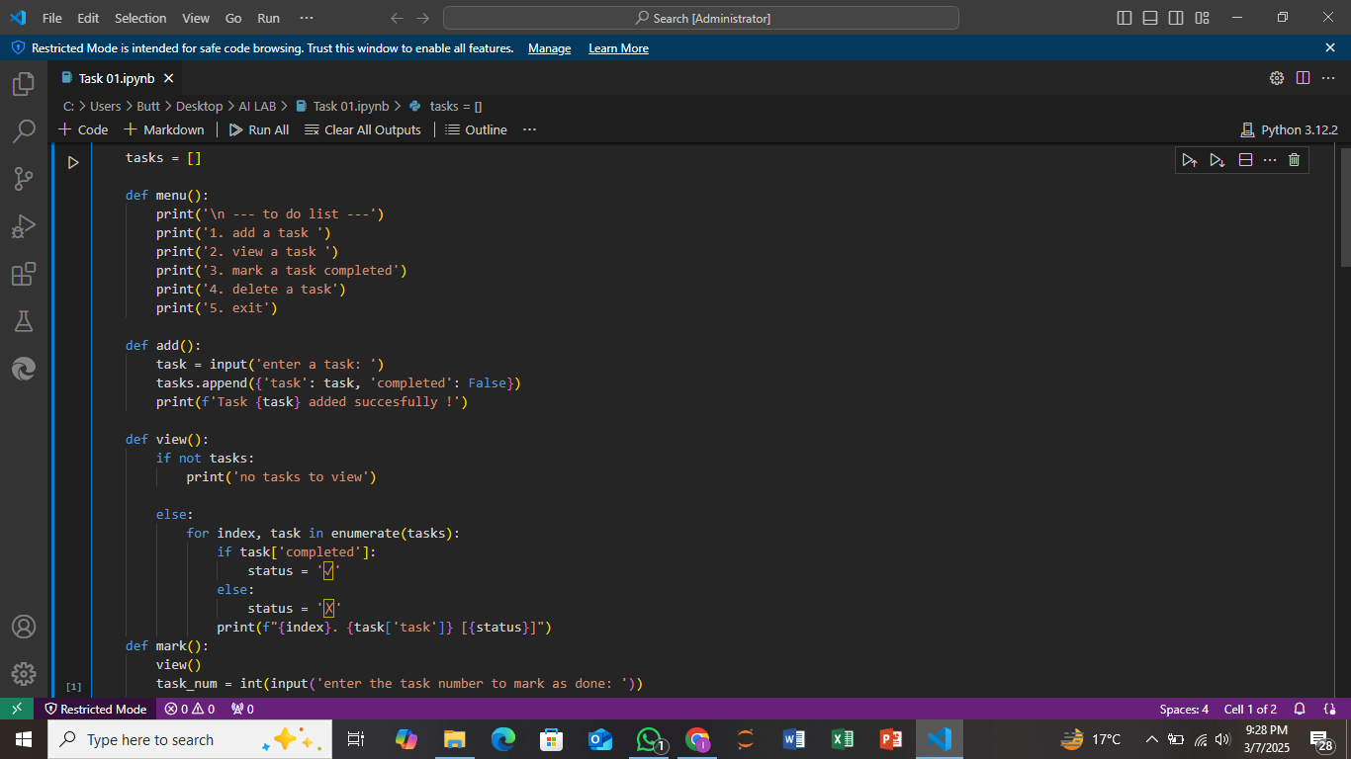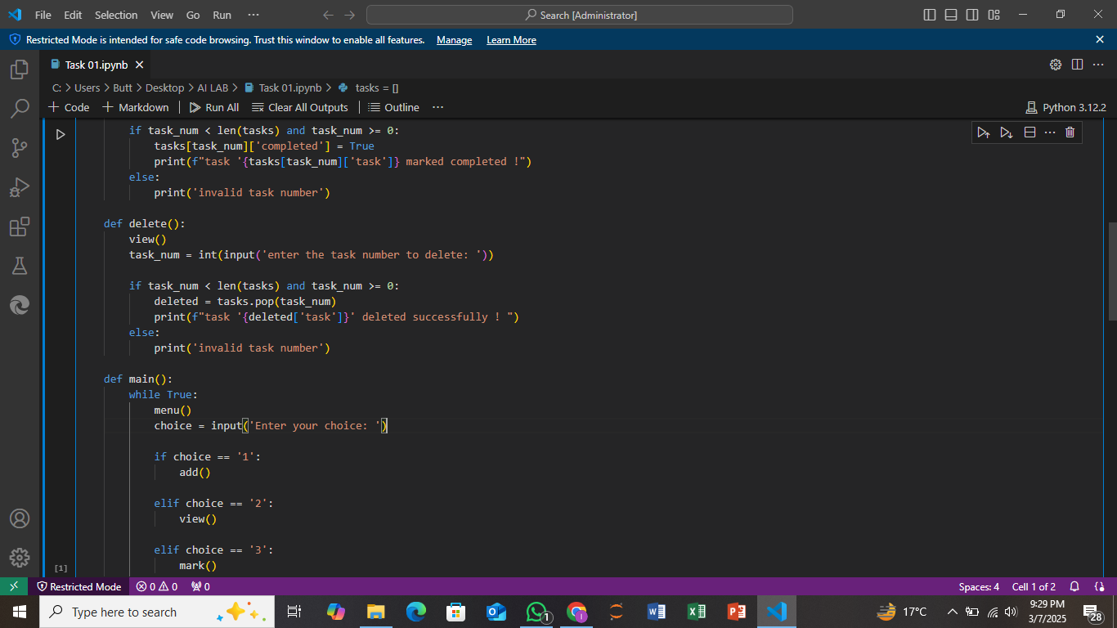

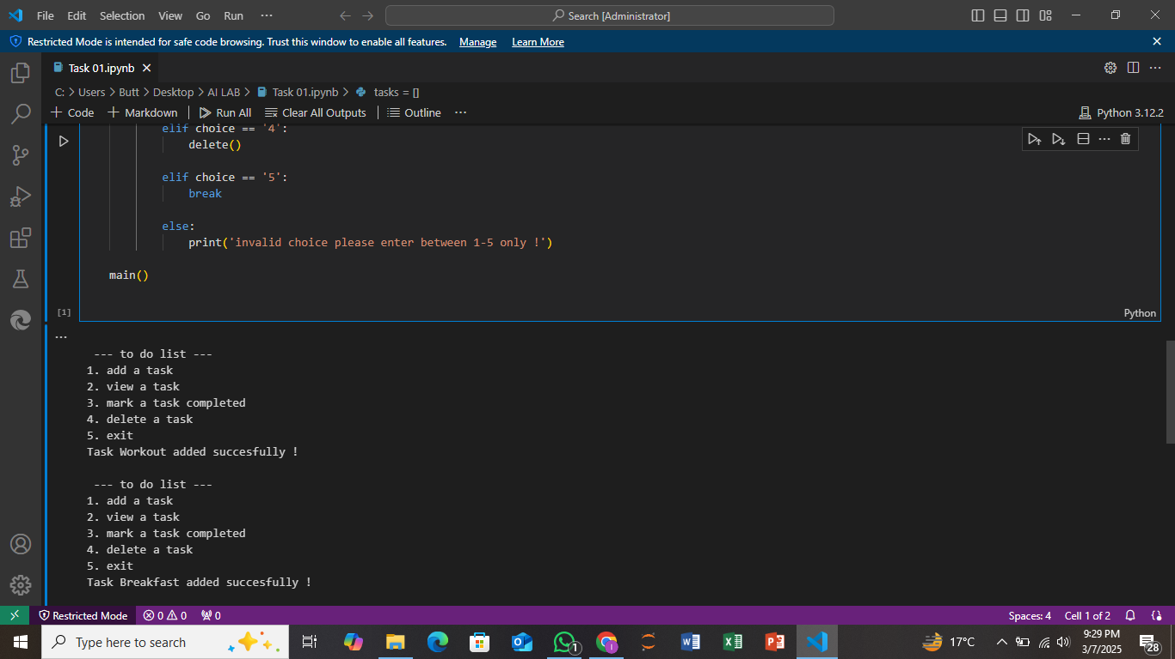

**Explanation:**

This program is a simple to-do list manager that allows users to add, view, mark, or delete tasks. The menu function displays a list of options for the user to choose from. The add function lets the user enter a new task and adds it to the task list, marking it as incomplete by default. The view function displays all tasks, showing whether they are completed or not with checkboxes (✗ for incomplete, ✓ for completed). The mark function allows the user to select a task by its number and mark it as completed. The delete function lets the user select a task and remove it from the list. The program runs continuously in a loop, allowing the user to choose different actions until they decide to exit. It ensures that only valid choices are made by checking task numbers and menu options.